COMBINED VARIATION
With Combined Variation, numbers are mixed, matched, computed, jumbled, and ultimately combined.
Combined variation mixes both direct and inverse variation. The general form looks like
Here, y varies directly with x, and y varies inversely with z.
- If x increases, y increases. If x decreases, y decreases.
- If z increases, y decreases. If z decreases, y increases.

Confused yet? Naw, take it one step at a time. Check out the sample problems below.

Sample Problem #1
If y varies directly with x and inversely with z, and y = 36 when x = 12 and z= 2, find y when x = 6 and z = 3.
First, write the general form for combined variation.
- Plug in the given values and solve for k.
- Cross-multiply and solve for k.
72 = 12k
k = 6
- Now, plug our k value into the general equation.
- Now, find y when x = 6 and z = 3.
y = 12

You Try: If y varies directly as x and inversely as z, and y = 22 when x = 4 and z = 6, find y when x = 10 and z = 25.
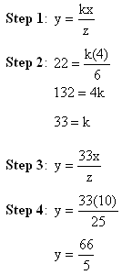
2. The volume of gas varies directly as the temperature and inversely as the pressure. If the volume is 230 cubic centimeters when the temperature is 300ºK and the pressure is 20 pounds per square centimeter, what is the volume when the temperature is 270 ºK and the pressure is 30 pounds per square centimeter?
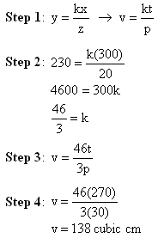
Challenge: If p varies directly as the square of q and inversely as the square root of r, and p = 60 when q = 6 and r = 81, find p when q = 8 and r = 144.
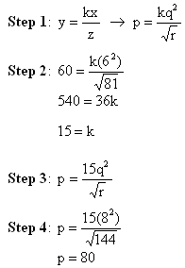

Combined Variation Word Problem:
The volume of wood in a tree (V) varies directly as the height (h) and inversely as the square of the girth (g). If the volume of a tree is 144 cubic meters when the height is 20 meters and the girth is 1.5 meters, what is the height of a tree with a volume of 1000 and girth of 2 meters?
Solution:
