**Name: ______________________ Block:__________________**

**Transformation Review HW**

***Multiple Choice***

Identify the choice that best completes the statement or answers the question.

**____ 1.** Write a description of the rule .

**(a)** translation 10 units to the right and 8 units up

**(b)** translation 10 units to the left and 8 units down

**(c)** translation 10 units to the right and 8 units down

**(d)** translation 10 units to the left and 8 units up

**____ 2.** Point *A* (–2, –10) is reflected over the *x*-axis. Write the coordinates of *A’*.

**(a)**  **(c)** 

**(b)**  **(d)** 

**____ 3.** Point *D* (2, 4) is rotated 180° about the origin, what is the coordinate of *D’*?

**(a)**  **(c)** 

**(b)**  **(d)** 

**____ 4.** Which of the following transformations does not result in a congruent figure?

**(a)** dilation **(c)** reflection

**(b)** rotation **(d)** translation

**____ 5.** What set of coordinates will provide the vertices for the translation of  two units to the left?



**(a)**  **(c)** 

**(b)**  **(d)** 

**____ 6.** If this triangle was reflected over the *y*-axis to form , what would be the

coordinates of vertex ?



**(a)**  **(c)** 

**(b)**  **(d)** 

**____ 7.** Using the graph below, what is the rule for a translation from point *A* to point *D*?

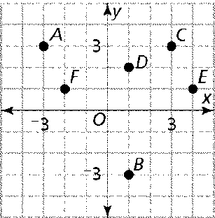

**(a)**  **(c)** 

**(b)**  **(d)** 

**____ 8.**  was dilated around the origin by a scale factor of 2. The endpoints of the image are  and . What are the coordinates of the endpoints of the original line segment?

**(a)**  **(c)** 

**(b)**  **(d)** 

**____ 9.** Point *X* (-3, -2) is translated using the rule , then reflected over the *x*-axis.What is the coordinate of *X”*?

**(a)**  **(c)** 

**(b)**  **(d)** 

**____ 10.** A rectangle is plotted on the coordinate plane below.



Which image shows a 90o clockwise rotation about the origin?



**(a)** **(c)**



**(b)** **(d)**

**11.** Polygon *ABCDE* is plotted on the grid below. ***(3pts)***



***Part A***

On the graph, draw the translation of polygon *ABCDE* eight units to the right and four units up. Label the image *A’B’C’D’E’*.

***Part B***

What are the coordinates of *A’*?

***Answer ______________***

***Part C***

Is the resulting figure similar or congruent to the original figure?

**12.** Quadrilateral *ABCD* is plotted on the grid below. ***(3pts)***



***Part A***

On the graph, draw the image of quadrilateral *ABCD* after a counterclockwise rotation of 90o about the origin. Label the image *A’B’C’D’*.

***Part B***

On the lines below, explain how the coordinates of *A* changed to the coordinates of .

__________________________________________________________________

__________________________________________________________________

__________________________________________________________________

**13.** The table below shows the coordinates of triangle *HKL*. ***(3pts)***

|  |  |  |  |
| --- | --- | --- | --- |
| **Triangle**  ***HKL*** | | **Triangle**  ***H’K’L’*** | |
| ***H*** | (-2, 3) | ***H’*** |  |
| ***K*** | (4, 2) | ***K’*** |  |
| ***L*** | (3, -2) | ***L’*** |  |

***Part A***

Fill in the table above for the coordinates of *H’, K’,* and *L’* after a reflection over the *x*-axis*.*

***Part B***

On the graph below, draw and label triangle *HKL* and triangle *H’K’L’*.



**14.** The table below shows the coordinates of triangle *RUN* and the coordinates of *R’* in

triangle *R’U’N’*. Triangle *R’U’N’* is a dilation of triangle *RUN*. ***(3pts)***

|  |  |  |  |
| --- | --- | --- | --- |
| **Triangle**  ***RUN*** | | **Triangle**  ***R’U’N’*** | |
| ***R*** | (6, 4) | ***R’*** | (3, 2) |
| ***U*** | (-8, 0) | ***U’*** |  |
| ***N*** | (2, -2) | ***N’*** |  |

***Part A***

Fill in the table above for the coordinates of point *U’* and point *N’*.

***Part B***

On the graph below, draw and label triangle *R”U”N”* after a translation of *R’U’N’* using the rule .



***Part C***

Which part(s) of the resulting figure are congruent to the original?

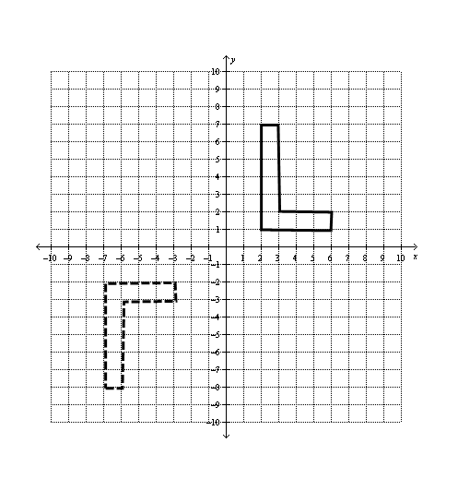**15.** Describe how you could move the solid polygon to exactly match the dashed polygon using a series of two transformations. ***(3pts)***

__________________________________________________________________

__________________________________________________________________

__________________________________________________________________

**16.** In the figure *ABCD* shown below, the total length of the sides equals 93 inches. ***(3pts)***



Find the length of side .

***Show your work.***

***Answer__________________________*** inches

**17. a)** In the figure, . Find *LM*.  ***(3 pts)***



**b)** What is the scale factor from  to ?

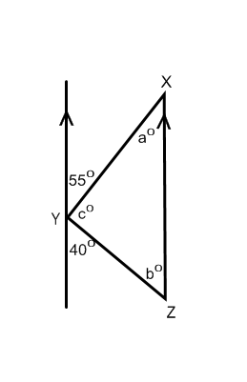

**18.** Label the missing angle measures. Explain how you arrived at your answer.  ***(3 pts)***