Unit 1B Review
Below are some practice problems around the material covered in Unit 1B. In addition to the below, please ensure you are using the warm up and other practice problems throughout your portfolio (the below are just a few SAMPLES). Complete blank pages in your notebook for extra practice (specifically projectile motion, systems and regression) and use my website for answer keys to check for accuracy.
1. A quadratic function has roots x = {-2/3, 5} and goes through the point (3,2).
Write this function in standard form

x = -2/3 and x = 5
3x = -2 x – 5 = 0
3x + 2 = 0
(3x + 2)(x – 5) = 0
3x² – 15x +2x – 10 = 0
3x² – 13x – 10 = 0
y = 3x2 – 13x - 10

2 = a(3(3)² – 13(3) – 10)
2 = a(27 – 39 - 10)
2 = -22(a)
-1/11 = a

Distribute the a value to the quadratic equation you got above:

Y = (-3/11)x² +13/11x +10/11

2. Convert the following quadratic function to vertex form: y = x² – 10x + 12

y – 12 = x2 – 10x
y – 12 + (10/2)2 = x2 – 10x + (10/2)2
y – 12 + 25 = x2 – 10x + 25
y + 13 = (x – 5)2
y = (x – 5)2 – 13

OR find the vertex (h, k), which is (5, -13), using –b/2a and plug into a(x – h)² + k

3. A parabola is modeled by the function -2x² + 9x - 3. Answer the following:

- What is the axis of symmetry?
x = -b/2a = -9/(2*-2) = 9/4 or 2.25
b. What are the coordinates of the vertex?

Plug 2.25 into the original equation for x to find your y: (2.25, 7.125)

c. What are the coordinates of the y-intercept?

(0, -3)

d. min or max? Negative = max

e. What are the zeroes?
Use the quadratic function to find {0.36, 4.14}

4. Solve the following system of equations algebraically
(remember: write your final answers as (x, y) coordinates).

y = x² + 10x – 3
2x = y + 18

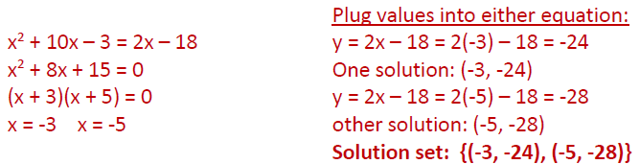

5. A projectile is launched upward. Readings for some heights and times are given in the following table:
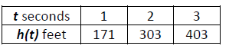

Using this information, answer the below:

Use stat menu, calculate a quadratic regression

h(t) = -16t2 + 180t + 7

- What is the height at 2.5 seconds?

Plug in 2.5 for t or use graph or table: h(2.5) = 357 ft

- What is the maximum height? h = 513.25 ft

- When will it reach its maximum height? t = 5.625 seconds

- When will it reach the ground? t = 11.29 seconds

- When will it reach 400 feet?

Set equal to 400 and solve t = 2.96 AND 8.285 seconds

- What is the initial velocity? 180

- What was the initial height? 7

6. A quadratic function has vertex (-3, 6) and goes through the point (-1, 18). Write this function in vertex form.

Tricky one because I didn’t give you a third point or enough info to find it! Use vertex form to plug in the other point.

18 = a(-1 – -3)2 + 6
18 = a(2)2 + 6
18 = 4a + 6
18 – 6 = 4a
12 = 4a
3 = a → y = 3(x + 3)² + 6

Use the quadratic function y = -3(x +1)² – 4 to answer questions #7-9:

7. What is the vertex of the function? __(-1, -4)____________

8. What is the axis of symmetry? ___x = -1___________

9. Does it have a minimum or maximum? _max_______ What is its value? __-4_______

10. Is the function y = 3x² + 8 even or odd?

3(-1)² + 8 stays the same, so its even (the graph is also symmetric across y axis)

